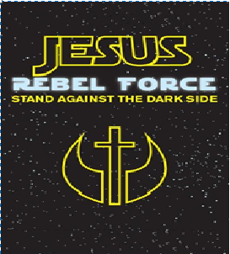
The light shines in the darkness, and the darkness has not overcome it. ( John 1:5) | Sunday School  Student Registration Form  2017-2018  Please complete one form per family.  Return to the Zion Lutheran Church Office  or your child’s Sunday School Teacher.

Name: First Middle Last | DOB | Date of Baptism | School Grade in Fall 2017

Parents’ Names: ______________________________________________________

Home/Mailing Address: __________________

Email Address: _____________________________________________

Phones: Home: _______________________

Dad Cell: ______________________________

Mom Cell: ____________________

Please circle the above phone number that is the best to contact you during Sunday School.

Please list any medical limitations, dietary restrictions, allergies: ______________________________________________

Please complete the back...

Zion Parents and Education Ministry Staff

In our continued effort to both prevent any possible harm to our children/youth and protect the staff of our education ministry, Zion strictly adheres to the "Two-Adult Rule". Both parents and staff can rest assured that for any child/youth event; either in a classroom setting or at an on- or off-premise event, a minimum of two adults (21 years of age or older) will be present.
The importance of this rule cannot be understated. Zion asks that both parents and staff sign below indicating that you are award of the "Two-Adult Rule" and that you will either help fill-in when additional adults are required, or understand when a class/event must be cancelled due to a lack of adult supervision.

Thank you ~ Renee Feldman & Marie Strebel ~ Sunday School Superintendents

I, _____________________________________________, have read and understand Zion's "Two-Adult Rule".

Signature:__________________________________________________________________________________

*******************************************************************

We are always in need of help; we have opportunities for a day or the year - and anything in between...

Please check your area(s) of interest:

Sunday School Teacher / Co-Teacher / Assistant / Substitute
Operation Christmas Child Assistant
Sunday School Christmas Pageant
Souper Bowl of Caring Leader
Pretzel Breakfast
Last Day of Sunday School
Confirmation Mentor
Jr. or Sr. Youth (Leader / Assistant)
Adult Forum
VBS 2018: circle area of interest: Director / Station Leader / Teacher / Assistant

