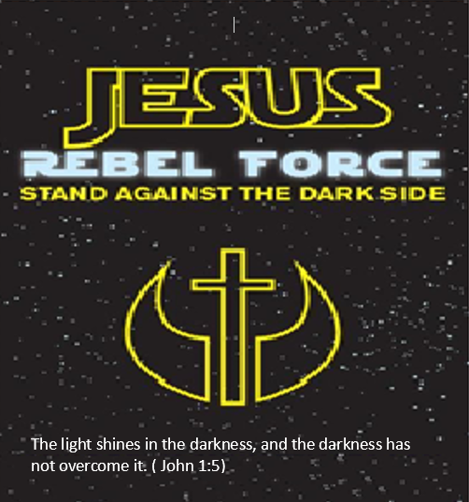
Media Release Form
We will be posting photos from Sunday School on our website and social media sites. Only photos will be posted, never any names. Please complete the authorization form below and return it to the Church Office or your Sunday School teacher. If you have any questions, please do not hesitate to contact us.
Renee: 908-310-9154 (call/text) or email rcrfeldman@yahoo.com
Marie: 201-906-8552 (call/text) or email mlstrebel@aol.com
Childs Name | Grade

No, I do not want photos of my child/children posted ____________
Yes, I agree to have photos of my child/children posted ____________

Parent Name: _______________________________________________

Parents Signature: ____________________________________________
Date: ______________________

